**2. spring-rest-Handson**

**Hello World RESTful Web Service   
  
Write a REST service in the spring learn application created earlier, that returns the text "Hello World!!" using Spring Web Framework. Refer details below:  
  
Method: GET  
URL: /hello  
Controller: com.cognizant.spring-learn.controller.HelloController  
Method Signature: public String sayHello()  
Method Implementation: return hard coded string "Hello World!!"  
Sample Request: http://localhost:8083/hello  
Sample Response: Hello World!!   
  
IMPORTANT NOTE: Don't forget to include start and end log in the sayHello() method.  
  
Try the URL http://localhost:8083/hello in both chrome browser and postman.  
  
SME to explain the following aspects:**

* **In network tab of developer tools show the HTTP header details received**
* **In postman click on "Headers" tab to view the HTTP header details received**

**Folder Structure:**

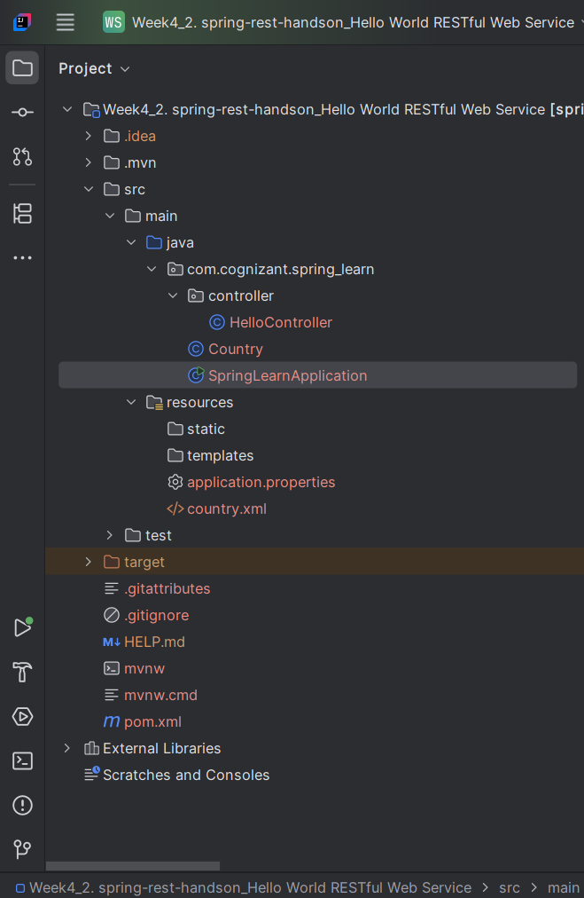

**Country.java**

package com.cognizant.spring_learn;  
  
import org.slf4j.Logger;  
import org.slf4j.LoggerFactory;  
  
public class Country {  
 private static final Logger *LOGGER* = LoggerFactory.*getLogger*(Country.class);  
  
 private String code;  
 private String name;  
  
 public Country() {  
 *LOGGER*.debug("Inside Country Constructor.");  
 }  
  
 public String getCode() {  
 *LOGGER*.debug("Inside getCode");  
 return code;  
 }  
  
 public void setCode(String code) {  
 *LOGGER*.debug("Inside setCode");  
 this.code = code;  
 }  
  
 public String getName() {  
 *LOGGER*.debug("Inside getName");  
 return name;  
 }  
  
 public void setName(String name) {  
 *LOGGER*.debug("Inside setName");  
 this.name = name;  
 }  
  
 @Override  
 public String toString() {  
 return "Country{" +  
 "code='" + code + '\'' +  
 ", name='" + name + '\'' +  
 '}';  
 }  
}

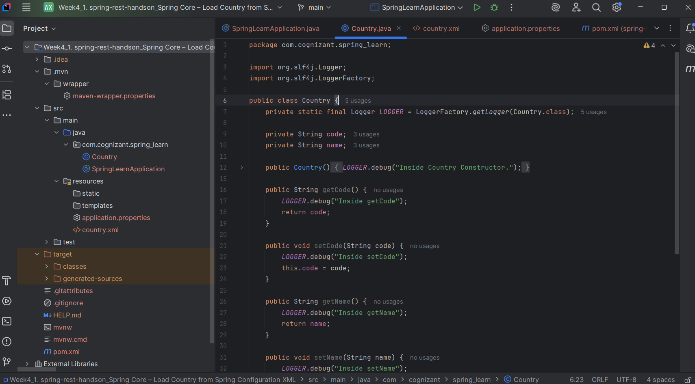

**country.xml (src/main/resources)**

<?xml version="1.0" encoding="UTF-8"?>  
<beans xmlns="http://www.springframework.org/schema/beans"  
 xmlns:xsi="http://www.w3.org/2001/XMLSchema-instance"  
 xsi:schemaLocation="http://www.springframework.org/schema/beans  
 https://www.springframework.org/schema/beans/spring-beans.xsd">  
  
 <bean id="country" class="com.cognizant.spring_learn.Country">  
 <property name="code" value="IN" />  
 <property name="name" value="India" />  
 </bean>  
  
</beans>

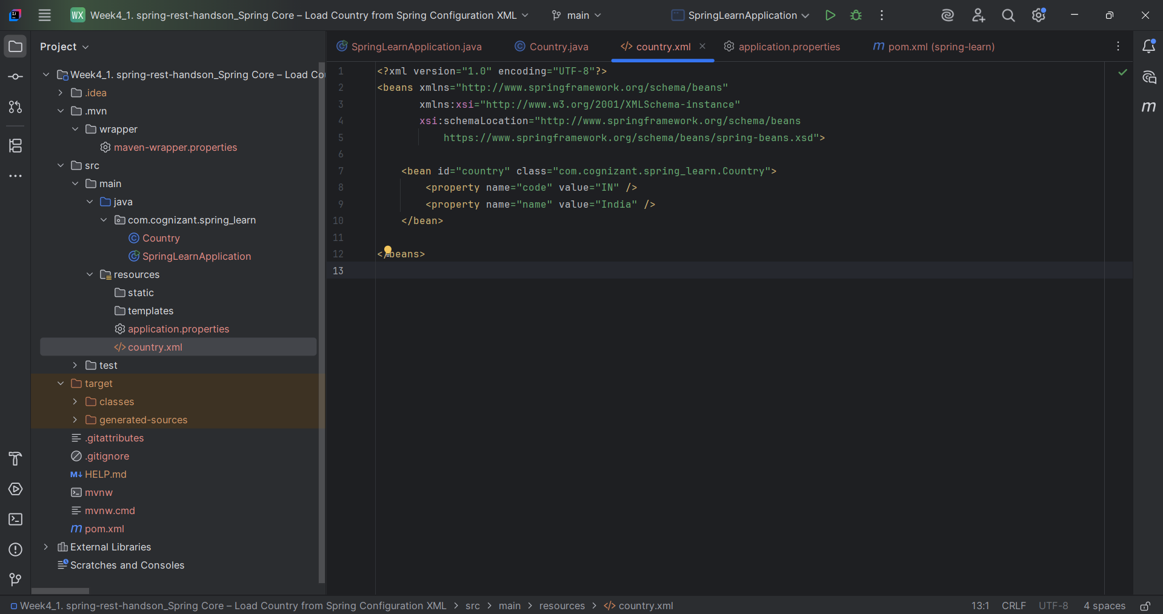

**application.properties (src/main/resources)**

spring.application.name=spring-learn  
logging.level.com.cognizant=DEBUG  
server.port=8083

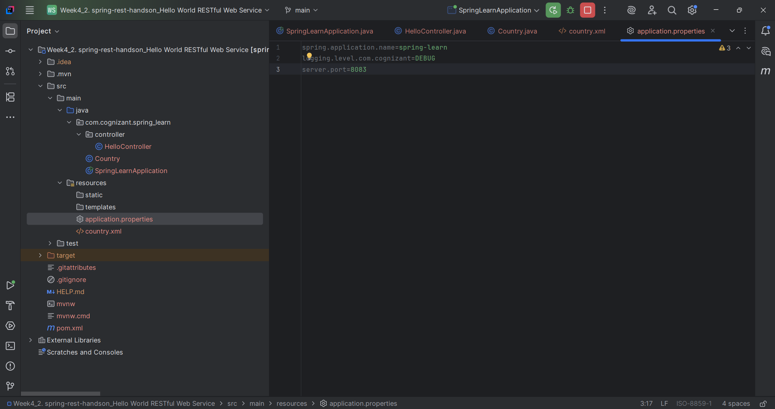

**SpringLearnApplication.java**

package com.cognizant.spring_learn;  
  
import org.slf4j.Logger;  
import org.slf4j.LoggerFactory;  
import org.springframework.boot.SpringApplication;  
import org.springframework.boot.autoconfigure.SpringBootApplication;  
import org.springframework.context.ApplicationContext;  
import org.springframework.context.support.ClassPathXmlApplicationContext;  
  
@SpringBootApplication  
public class SpringLearnApplication {  
  
 private static final Logger *LOGGER* = LoggerFactory.*getLogger*(SpringLearnApplication.class);  
  
 public static void main(String[] args) {  
 *LOGGER*.info("START");  
 SpringApplication.*run*(SpringLearnApplication.class, args);  
 *displayCountry*();  
 *LOGGER*.info("END");  
 }  
  
 public static void displayCountry() {  
 ApplicationContext context = new ClassPathXmlApplicationContext("country.xml");  
 Country country = (Country) context.getBean("country", Country.class);  
 *LOGGER*.debug("Country : {}", country.toString());  
 }  
}

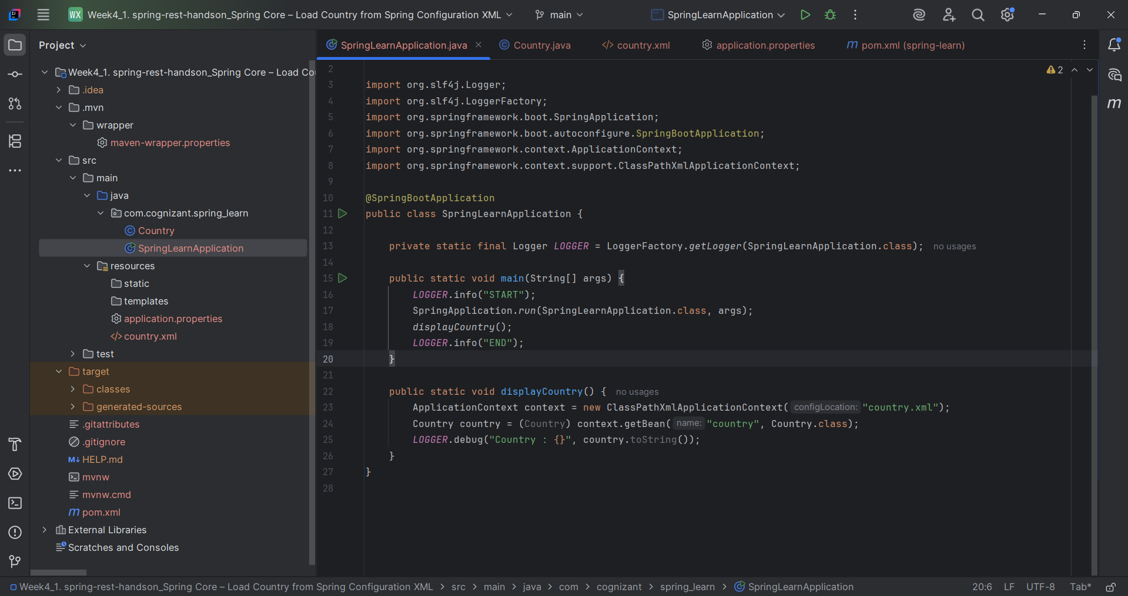

**HelloController.java**

package com.cognizant.spring_learn.controller;  
  
import org.slf4j.Logger;  
import org.slf4j.LoggerFactory;  
import org.springframework.web.bind.annotation.*;  
  
@RestController  
public class HelloController {  
  
 private static final Logger *LOGGER* = LoggerFactory.*getLogger*(HelloController.class);  
  
 @GetMapping("/hello")  
 public String sayHello() {  
 *LOGGER*.info("START");  
 String response = "Hello World!!";  
 *LOGGER*.info("END");  
 return response;  
 }  
}

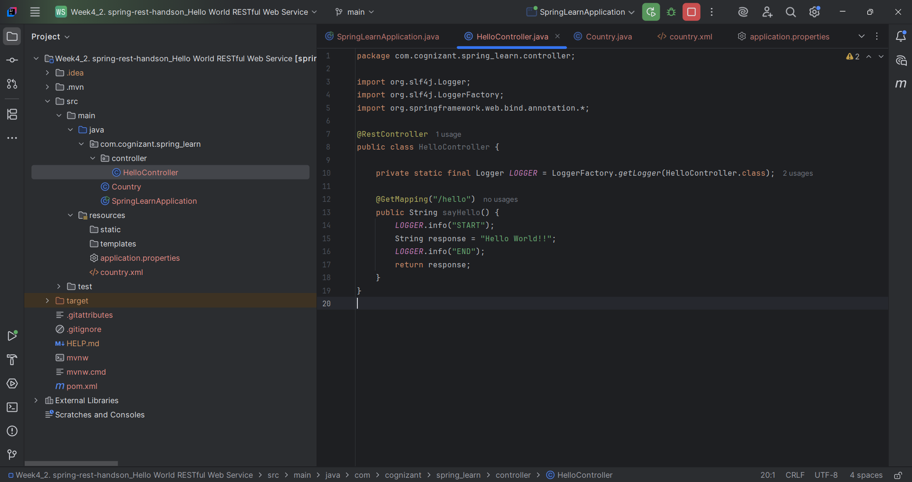

**pom.xml**

<?xml version="1.0" encoding="UTF-8"?>  
<project xmlns="http://maven.apache.org/POM/4.0.0" xmlns:xsi="http://www.w3.org/2001/XMLSchema-instance"  
 xsi:schemaLocation="http://maven.apache.org/POM/4.0.0 https://maven.apache.org/xsd/maven-4.0.0.xsd">  
 <modelVersion>4.0.0</modelVersion>  
 <parent>  
 <groupId>org.springframework.boot</groupId>  
 <artifactId>spring-boot-starter-parent</artifactId>  
 <version>3.5.3</version>  
 <relativePath/> <!-- lookup parent from repository -->  
 </parent>  
 <groupId>com.cognizant</groupId>  
 <artifactId>spring-learn</artifactId>  
 <version>0.0.1-SNAPSHOT</version>  
 <name>spring-learn</name>  
 <description>Demo project for Spring Boot</description>  
 <url/>  
 <licenses>  
 <license/>  
 </licenses>  
 <developers>  
 <developer/>  
 </developers>  
 <scm>  
 <connection/>  
 <developerConnection/>  
 <tag/>  
 <url/>  
 </scm>  
 <properties>  
 <java.version>17</java.version>  
 </properties>  
 <dependencies>  
 <dependency>  
 <groupId>org.springframework.boot</groupId>  
 <artifactId>spring-boot-starter-web</artifactId>  
 </dependency>  
  
 <dependency>  
 <groupId>org.springframework.boot</groupId>  
 <artifactId>spring-boot-devtools</artifactId>  
 <scope>runtime</scope>  
 <optional>true</optional>  
 </dependency>  
 <dependency>  
 <groupId>org.springframework.boot</groupId>  
 <artifactId>spring-boot-starter-test</artifactId>  
 <scope>test</scope>  
 </dependency>  
 </dependencies>  
  
 <build>  
 <plugins>  
 <plugin>  
 <groupId>org.springframework.boot</groupId>  
 <artifactId>spring-boot-maven-plugin</artifactId>  
 </plugin>  
 </plugins>  
 </build>  
  
</project>

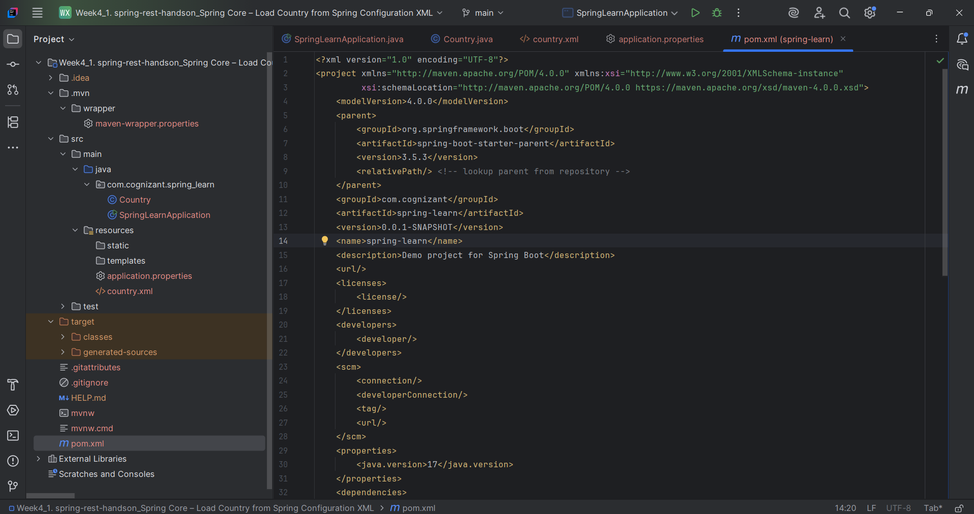

**Output:**

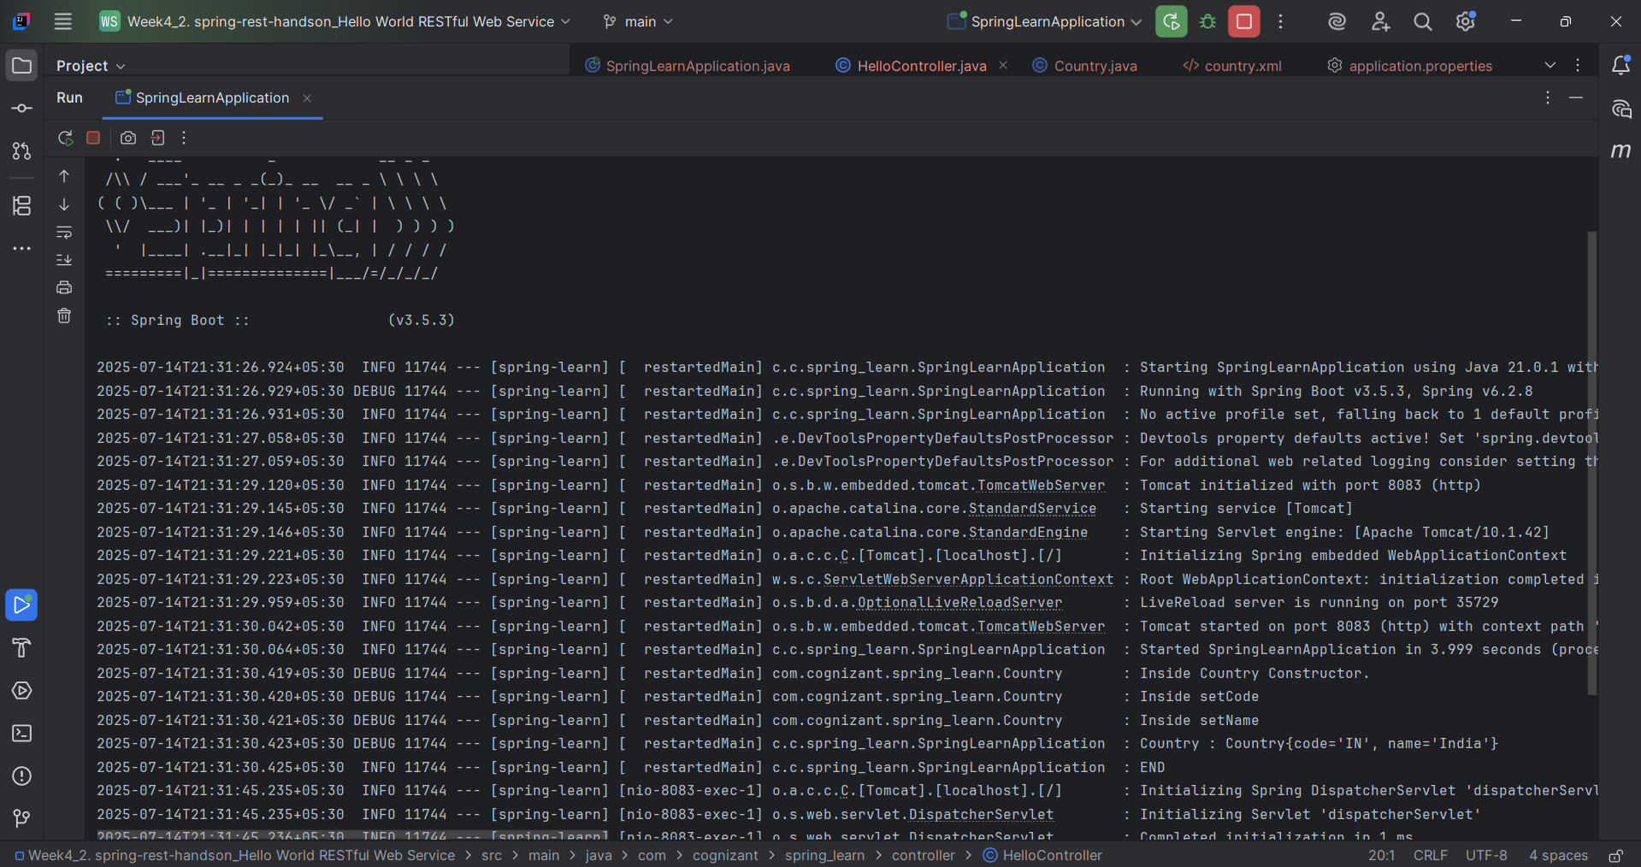

**Browser**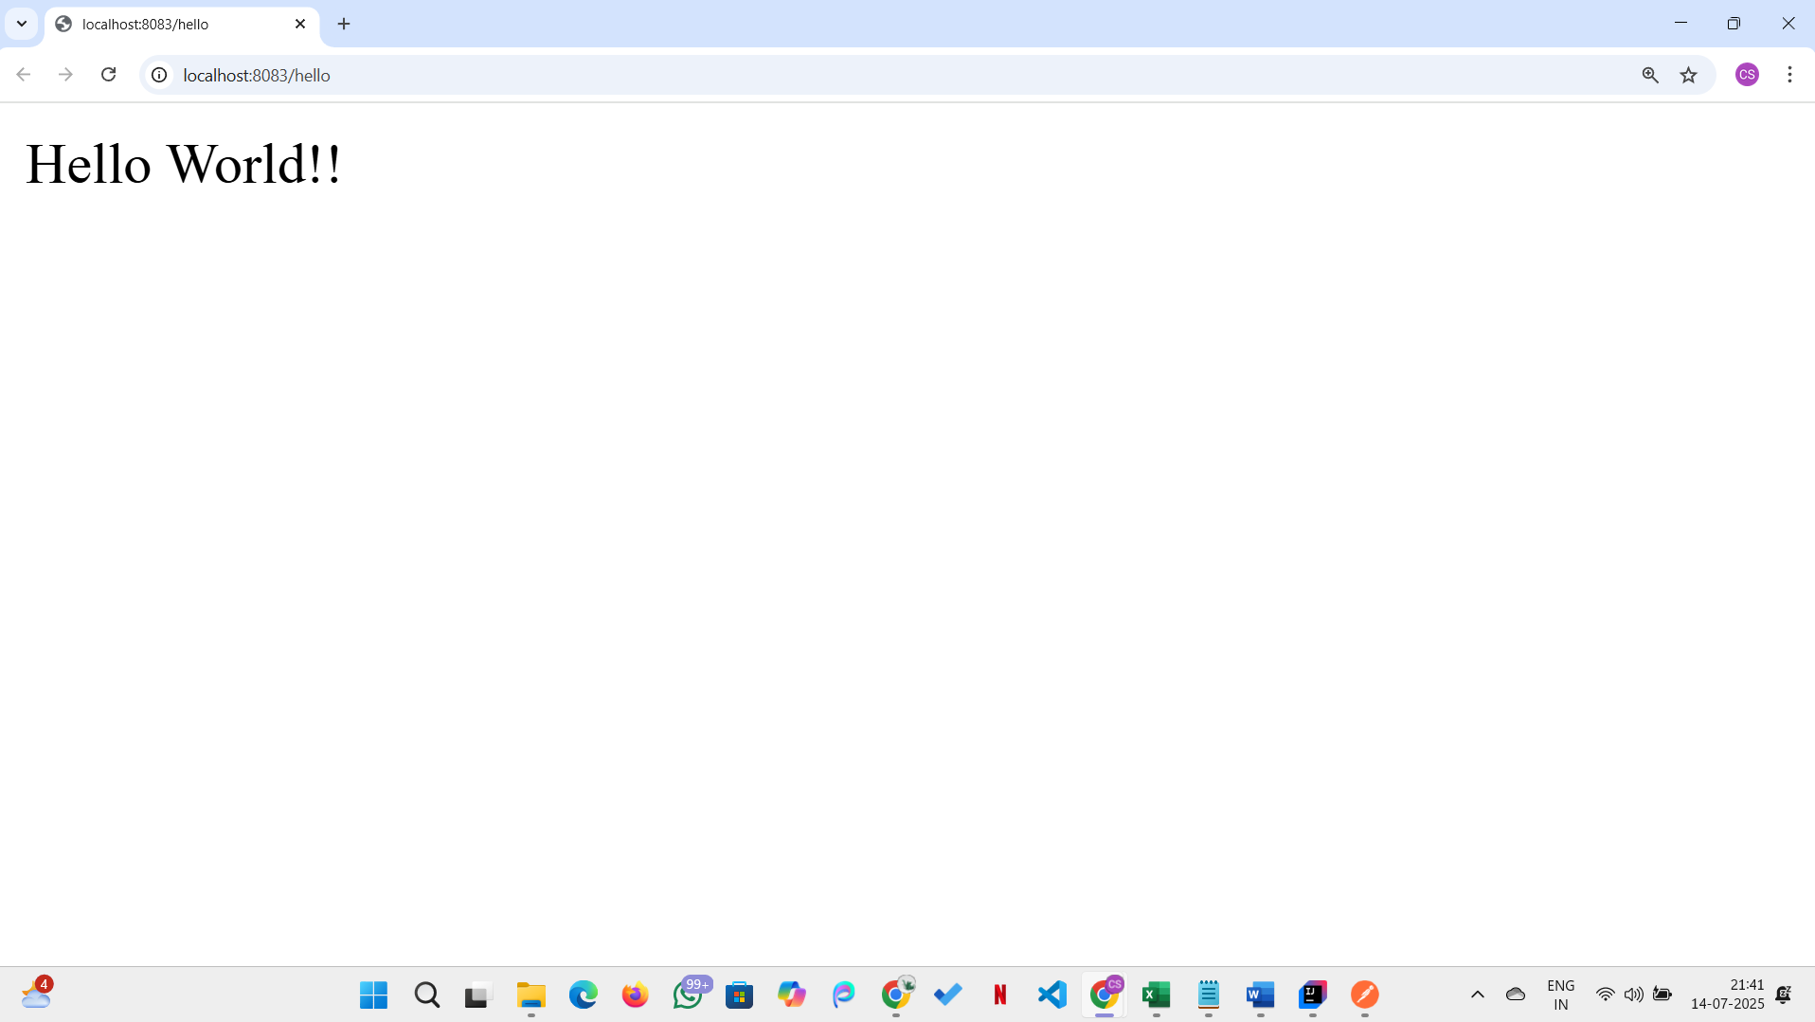

**PostMan**

